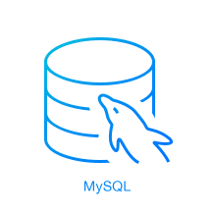

**DATABASE PROJECT:**

**Santa and MySQL**

**Building a database for christmas requests, santa’s elves, and gift distribution**

**OLUSEGUN EMMANUEL AJIBOLA | DATABASE SYSTEMS | 19 February 2022**

Table of Contents

**INTRODUCTION** 2

**METHODOLOGY** 3

**Organizational Hierarchy** 3

**E-R Diagram** 3

**Relationships** 5

**Relational Database Schema** 6

**MySQL Workbench** 6

**CHALLENGES** 7

**CONCLUSION** 8

FIGURES

Figure 1: Organization Hierarchy and Departments 3

Figure 2 E-R Model Showing Entities and Attributes 4

Figure 3: Relationship Diagram 5

Figure 4: Relationships and Entity-Attributes Modelling 5

Figure 5: The relational database schema 6

Figure 6: EER Table after implementation 7

Figure 7: Flow of database build 8

# **INTRODUCTION**

It's holiday time and Christmas has just passed. The number of gifts has grown tremendously over the years and Santa Claus has realized that the elves need to be helped by new technologies. For this reason, Santa Claus wants to create a database that can help him in this arduous task.

Santa Claus will have to manage on the one hand the requests for gifts and on the other hand their production and delivery.

Gift production is organized in the following manner:

Each type of gift is characterized by a name, its size, the colours from which it is composed, the type (high-tech, food, clothing, etc.), the localization version (e.g., Italian, Spanish, German, etc.), a number identifying the version since the gifts are updated from year to year, the list and quantity in grams of the raw materials necessary for its production (wood, iron, plastic, etc.), and an indicator (0,1] of the complexity of its production (where 1 represents maximum complexity).

For each type of gift, a certain quantity is produced based on 75% of the previous year's demand before the autumn time. Each gift produced will have its serial code and the lot in which it was produced.

Santa's elves take care of the production of the gifts and some of them also prepare the loads for shipping. The elves then organized themselves into departments and sub-departments. Each department is aligned with the types of gifts/tasks (high-tech, food, dress, shipping, etc.) and manages the sub-departments. Each sub-department handles the production of a few specific versions of gifts. Each sub-department has a manager who is in charge of checking and distributing the load on the elves.

Each elf is characterized by his/her name and years of experience and daily makes a certain number of pieces of a certain version of gift.

To prevent the elves from getting too tired each elf cannot produce more than a number of gifts equal to 30 in total complexity (the sum of the complexities of the gifts produced) per day.

Each department has a manager who has to monitor the raw materials at his disposal in order to reorder them.

The shipment department does not have any sub-department but has some elves in each department that are in charge to organise their portion of the load. The other elves in the shipment department are in charge of finalising and scheduling the loads.

# **METHODOLOGY**

To help Santa Claus achieve his aim, we model a database using MySQL as the structured query language which solves the problem at hand. Furthermore, MySQL Workbench was used in the process alongside some relevant concepts such as entity relation (E-R) diagram, relational database schema, Enhanced Entity-Relationship (EER) diagrams, also including the Data definition Language (DDL) and Data Manipulation Language (DML). We also use the diagram tool draw.io (<https://app.diagrams.net/>) to build the E-R diagram and the relationships involved, and also the relational database schema.

## **Organizational Hierarchy**

The Christmas Ville (where Santa and his elves stay) organizational hierarchy is given as below:

Figure : Organization Hierarchy and Departments

For this year, we are restricted to the above five (5) departments with Santa overseeing the general affairs of the organization. Since every department has a subdepartment except the shipping department, we take it that the shipping department has only one subdepartment i.e. itself (shipping).

## **E-R Diagram**

We translate the entity-relationship diagram as given below:

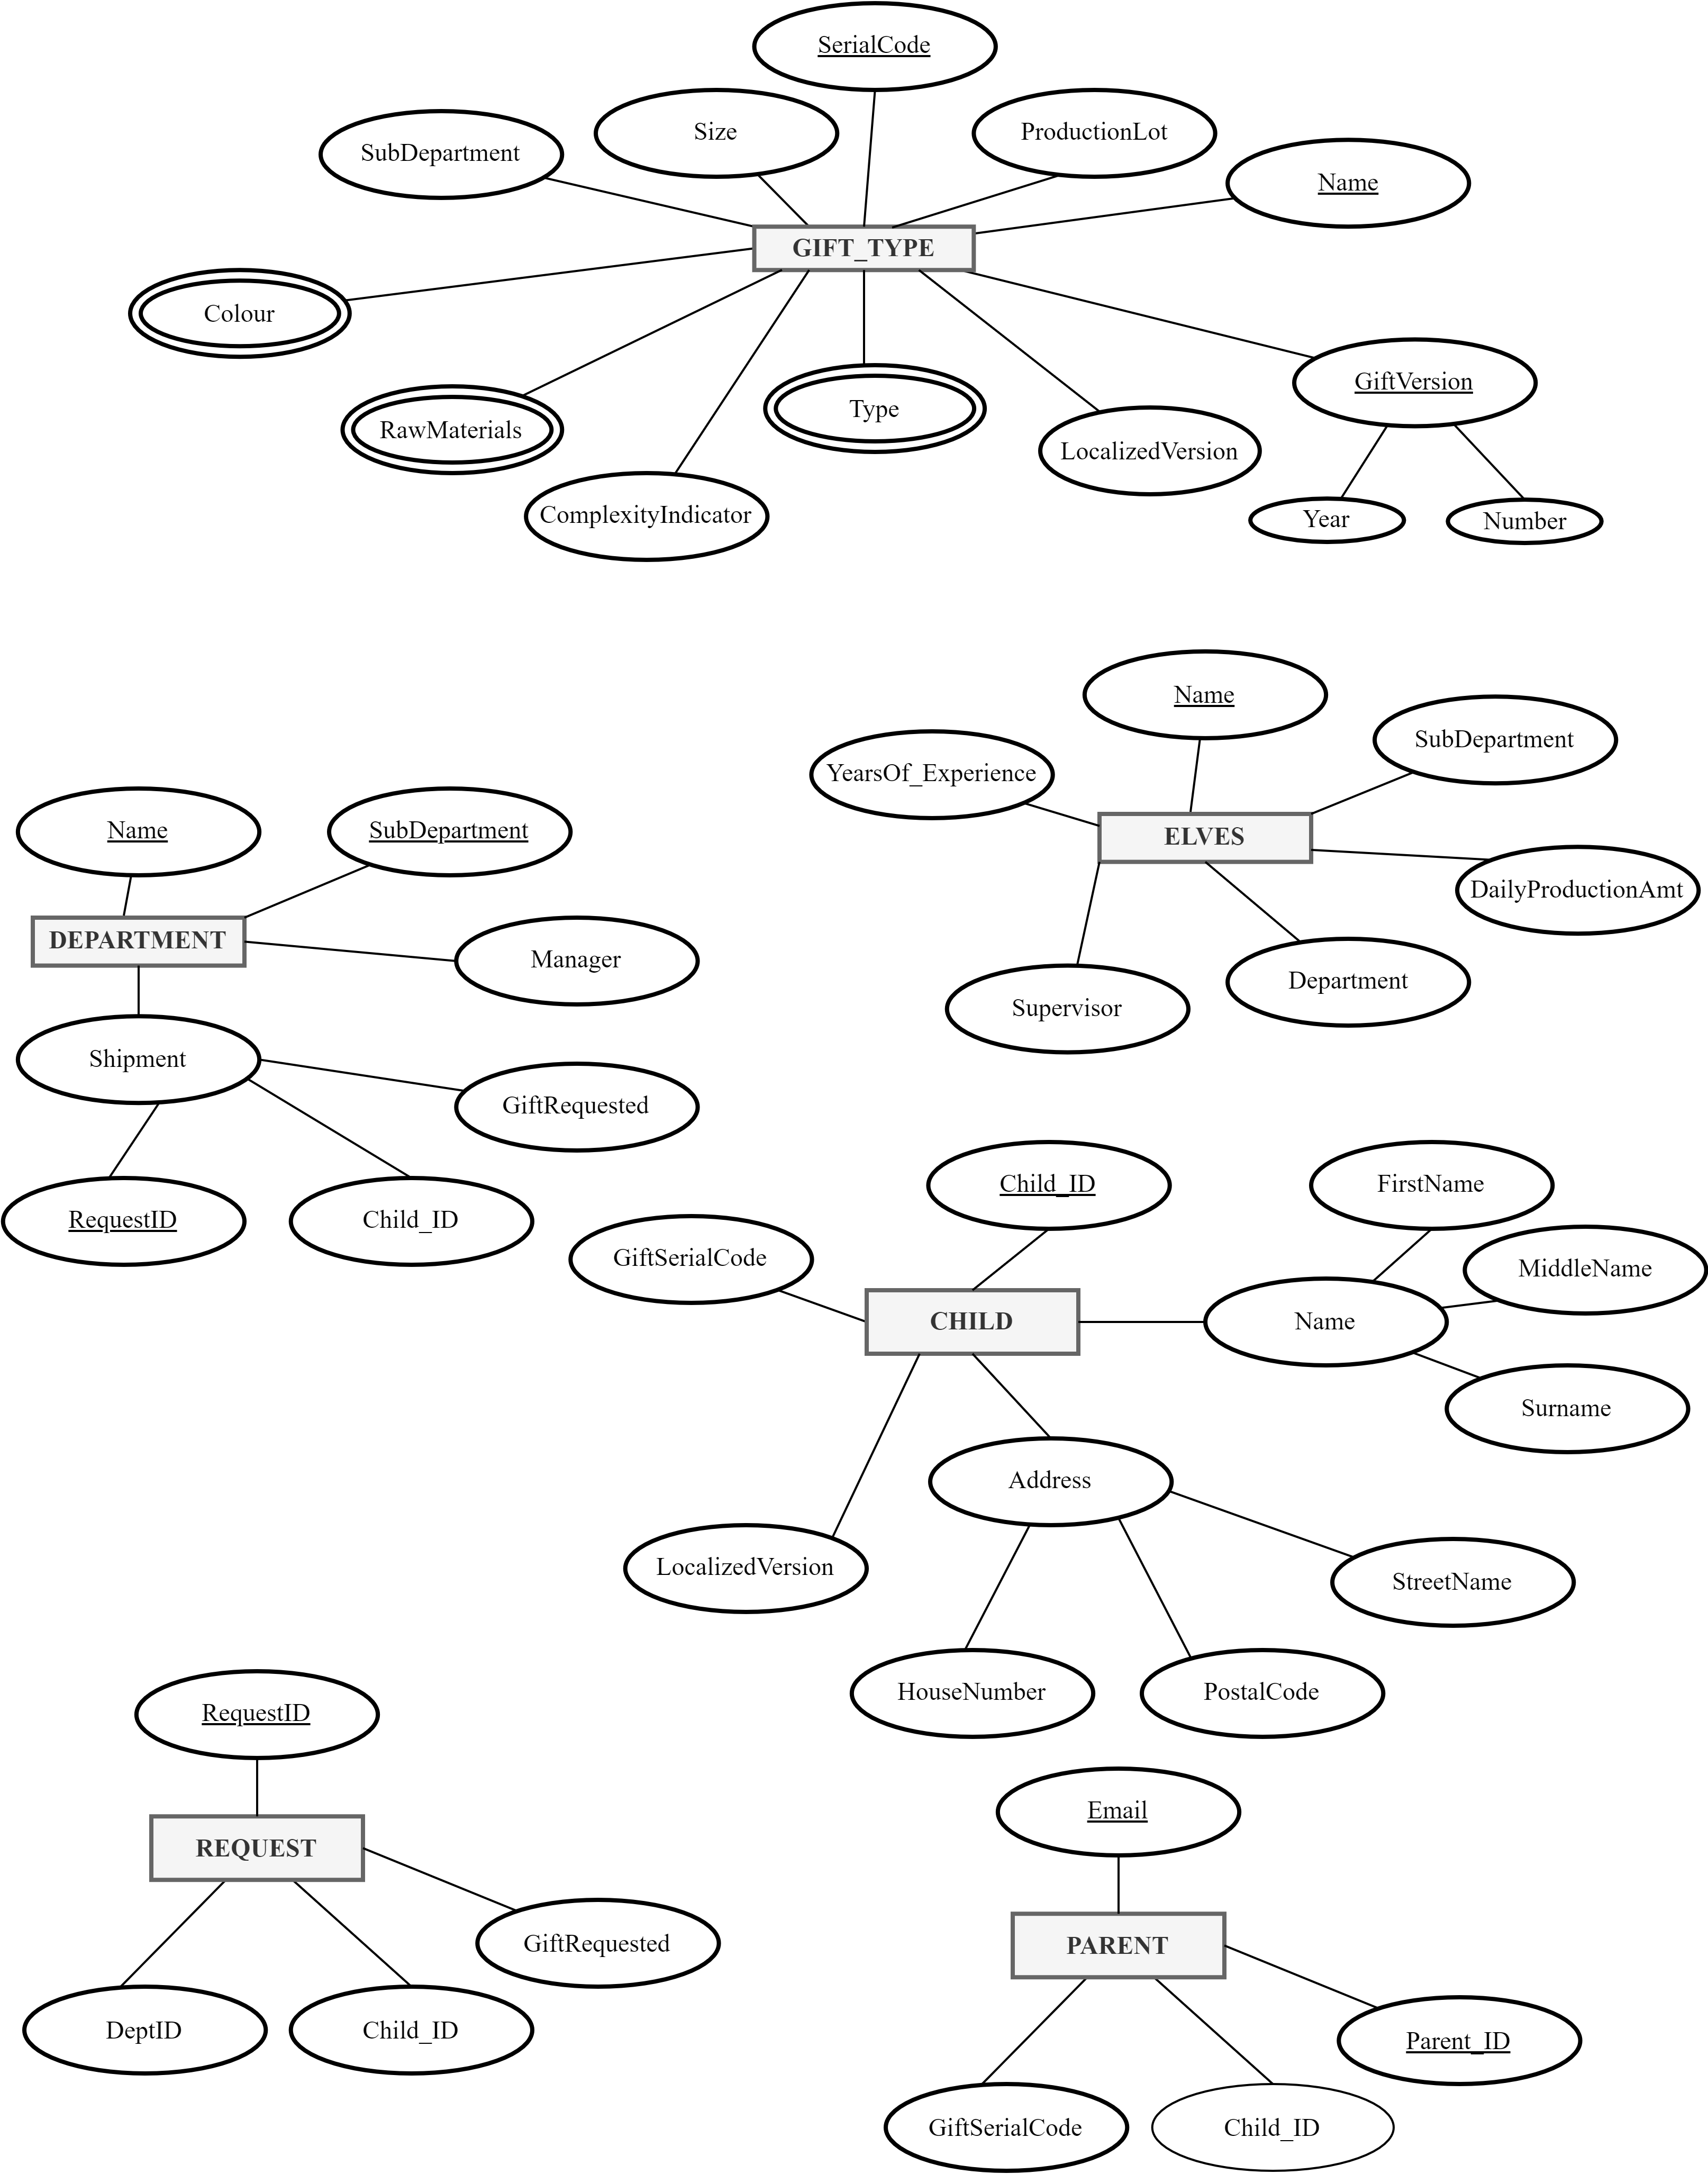

Figure E-R Model Showing Entities and Attributes

## **Relationships**

The relationship in the database is given below:

Figure : Relationship Diagram

Figure : Relationships and Entity-Attributes Modelling

## **Relational Database Schema**

Furthermore, we model the relational database schema and we get the figure below.

Figure : The relational database schema

## **MySQL Workbench**

So far, we have visualized the diagrams (or relationship schemas) without implementing them in a real database. Using MySQL Workbench gave us some challenges which we had to tweak the model already built using schemas to accommodate the constraints available in MySQL.

At the end of the day, we have the EER table given below.

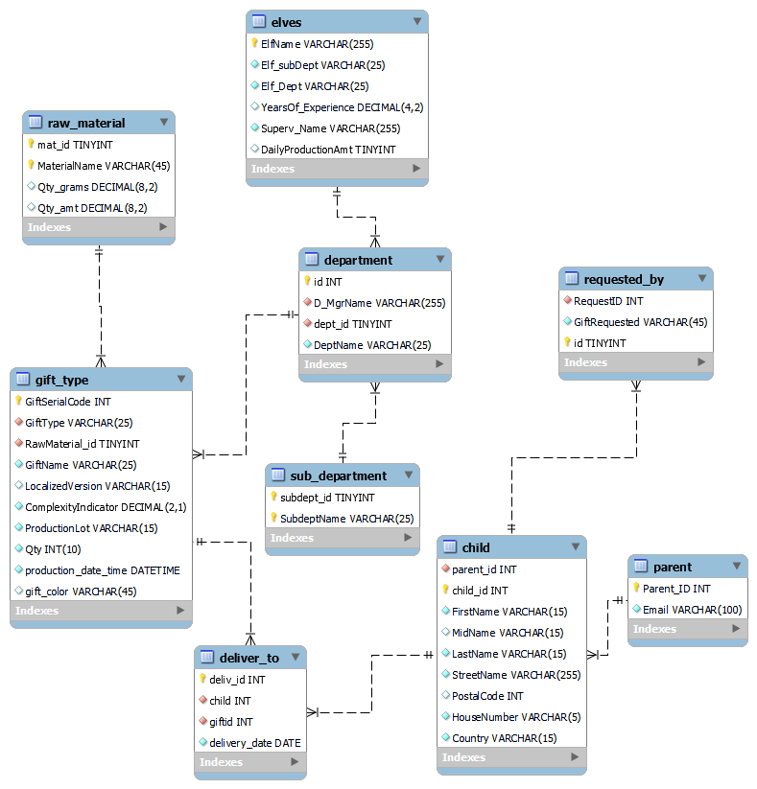

Figure : EER Table after implementation

# **CHALLENGES**

Firstly, kindly refer to the scripts and workbench files made available for the project.

We list the challenges we encountered while trying to deliver on this project to make the kids and Santa Claus happy for the implementation of this project.

* As mentioned earlier, the shipping department had to have itself be a subdepartment to defeat the **NOT NULL** constraint since all departments were made to be primary keys (**PK**).
* A requirement for the project was loading CSV files into the database, MySQL already made this available using the import/export tab, nonetheless, a snippet of a muted (commented) code was made available for this.
* To avoid error while working on the database, the figure below gives a step-by-step approach to work on the database

Figure : Flow of database build

# **CONCLUSION**

This report gives detail on creating a database for Santa Claus alongside how the database was made to accommodate Santa’s request.